**Experiment No.05**

**PART A**

(PART A : TO BE REFFERED BY STUDENTS)

**To implement basic connection establishment by using Packet Tracer Software**

**A.1—Aim:**

The purpose of this session is to implement the basic connection and sending echo messages from one device to another via switches using packet tracer software

**A.2--- Prerequisite:**

Understanding the basic knowledge of connecting devices

**A.3--- Outcome:**

After successful completion of this experiment students will be able to:

• Interact the basic interface of the Packet tracer software

**A.4--- Procedure:**

**Task:**

1. To connect client to server

2. See the simulation of sent and received packet using general and complex PDU

3. Check the OSI layers of the packet

*4.* Observe the output and complete PART B of lab manual

5. Save and close the file and name it as **EXP 5_ your Roll no.**

**(PART - B)**

(TO BE COMPLETED BY STUDENTS)

(Students must submit the soft copy as per following segments within two hours of the practical. The soft copy must be uploaded on the Blackboard or emailed to the concerned lab in charge faculties at the end of the practical in case there is no Black board access available)

|  |  |
| --- | --- |
| Roll. No. A016 | Name: Varun Mahendra Khadayate |
| Class B.Tech CsBs | Batch: 1 |
| Date of Experiment: 05-02-2022 | Date of Submission:28-03-2022 |

**B.1: Procedure of performed experiment**

(Students are expected to write the procedure of performed experiment)

1. In Cisco Packet Tracer, create a connection in Logical Mode.

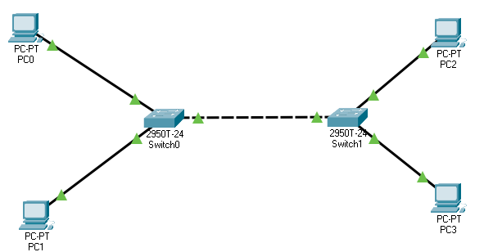

1. Click on all the PC simultaneously and click on Desktop and select IP Configuration, a new box will open. In that box under the IP Configuration section, assign the IP addresses as 192.168.10.1, 192.168.10.2, 192.168.10.3 and 192.168.20.4 respectively of all the PC

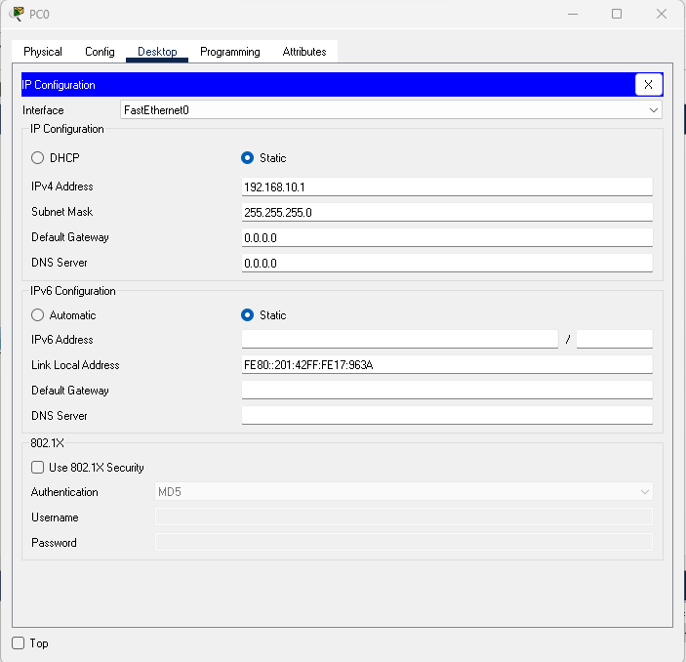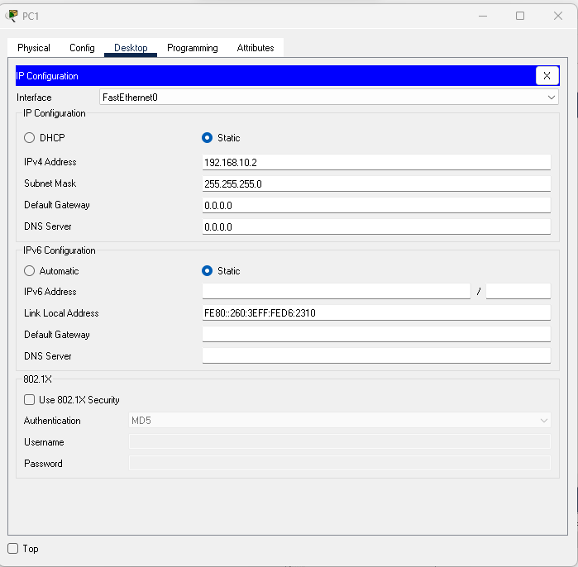

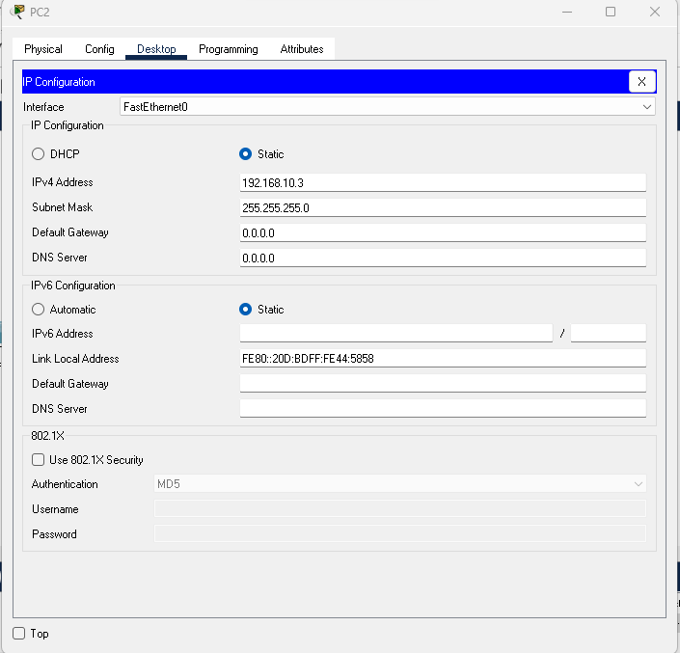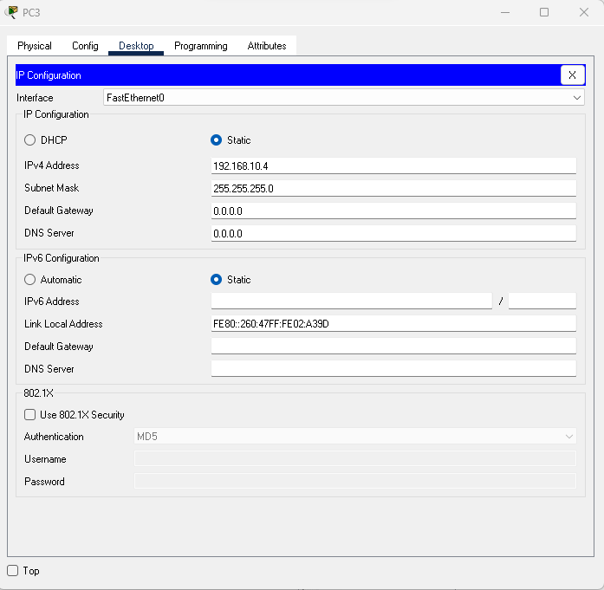

1. Now from the task bar select the ‘Add simple PDU’ button and select PC0 one by one and start the simulation to see the message parsing.

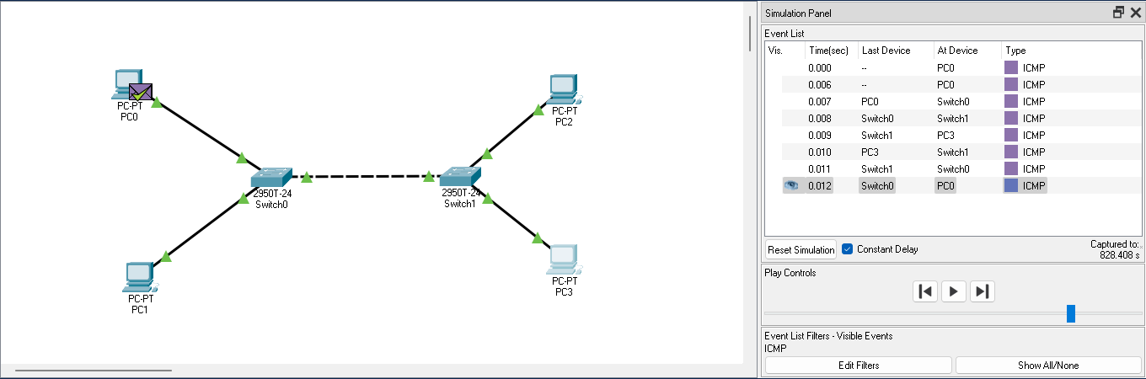

**B.2: Observations and Learning’s:**

(Students are expected to comment on the output obtained with clear observations and learning for each task/ sub part assigned)

### Initial State:

#### Layer 1

1. FastEthernet0 sends out the frame.

#### Layer 2

1. The next-hop IP address is a unicast. The ARP process looks it up in the ARP table.

2. The next-hop IP address is not in the ARP table. The ARP process tries to send an ARP request for that IP address and buffers this packet.

1. The ARP process takes out this packet from the buffer and resends it.

2. The device encapsulates the PDU into an Ethernet frame.

#### Layer 3

1. The Ping process starts the next ping request.

2. The Ping process creates an ICMP Echo Request message and sends it to the lower process.

3. The device sets TTL in the packet header.

4. The destination IP address is in the same subnet. The device sets the next-hop to destination.

### PC0 to Switch0:

#### In Layer 1:

FastEthernet0/1 receives the frame.

#### In Layer 2:

1. The frame source MAC address was found in the MAC table of Switch.

2. This is a unicast frame. Switch looks in its MAC table for the destination MAC address.

#### Out Layer 1:

FastEthernet0/3 sends out the frame.

#### Out Layer 2:

The outgoing port is an access port. Switch sends the frame out that port.

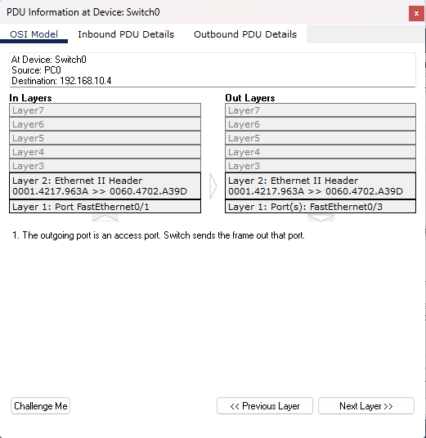

### Switch0 to Switch1

#### In Layer 1

1. FastEthernet0/3 receives the frame.

#### In Layer 2

1. The frame source MAC address was found in the MAC table of Switch.

2. This is a unicast frame. Switch looks in its MAC table for the destination MAC address.

#### Out Layer 1

1. FastEthernet0/2 sends out the frame.

#### Out Layer 2

1. The outgoing port is an access port. Switch sends the frame out that port.

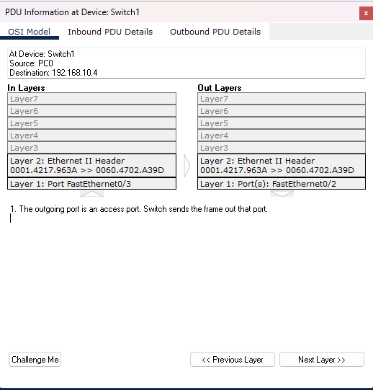

### Switch1 to PC3

#### In layer 1

FastEthernet0 receives the frame.

#### In Layer 2

1. The frame's destination MAC address matches the receiving port's MAC address, the broadcast address, or a multicast address.

2. The device decapsulates the PDU from the Ethernet frame.

#### In Layer 3

1. The packet's destination IP address matches the device's IP address or the broadcast address. The device de-encapsulates the packet.

2. The packet is an ICMP packet. The ICMP process processes it.

3. The ICMP process received an Echo Request message.

#### Out Layer 1

FastEthernet0 sends out the frame.

#### Out Layer 2

1. The next-hop IP address is a unicast. The ARP process looks it up in the ARP table.

2. The next-hop IP address is in the ARP table. The ARP process sets the frame's destination MAC address to the one found in the table.

3. The device encapsulates the PDU into an Ethernet frame.

#### Out Layer 3

1. The ICMP process replies to the Echo Request by setting ICMP type to Echo Reply.

2. The ICMP process sends an Echo Reply.

3. The destination IP address is in the same subnet. The device sets the next-hop to destination.

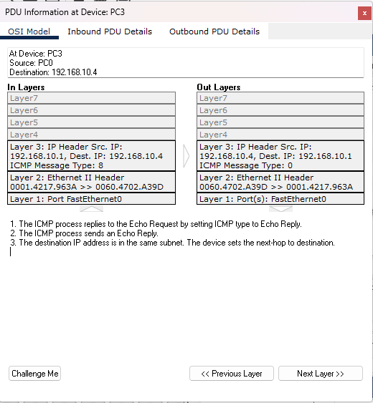

### PC3 to Switch1

#### In Layer 1

FastEthernet0/2 receives the frame.

#### In Layer 2

1. The frame source MAC address was found in the MAC table of Switch.

2. This is a unicast frame. Switch looks in its MAC table for the destination MAC address.

#### Out Layer 1

FastEthernet0/3 sends out the frame.

#### Out Layer 2

The outgoing port is an access port. Switch sends the frame out that port.

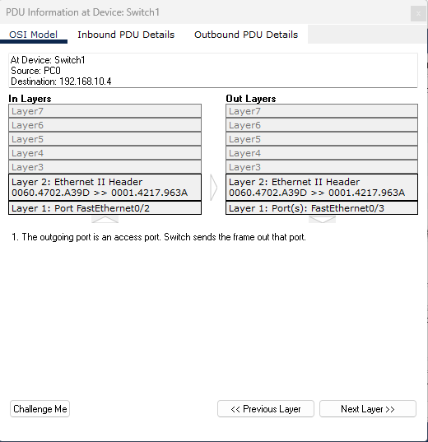

### Switch1 to Switch0

#### In Layer 1

FastEthernet0/3 receives the frame.

#### In Layer 2

1. The frame source MAC address was found in the MAC table of Switch.

2. This is a unicast frame. Switch looks in its MAC table for the destination MAC address.

#### Out Layer 1

FastEthernet0/1 sends out the frame.

#### Out Layer 2

The outgoing port is an access port. Switch sends the frame out that port.

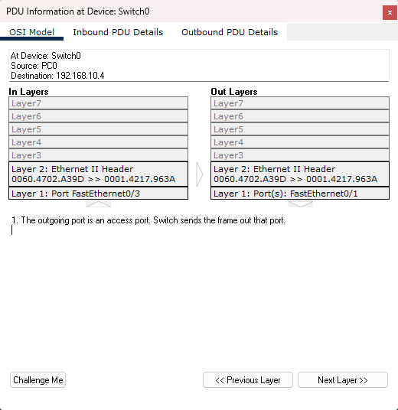

### Switch0 to PC0

#### In Layer 1

FastEthernet0 receives the frame.

#### In Layer 2

1. The frame's destination MAC address matches the receiving port's MAC address, the broadcast address, or a multicast address.

2. The device decapsulates the PDU from the Ethernet frame.

#### In Layer 3

1. The packet's destination IP address matches the device's IP address or the broadcast address. The device de-encapsulates the packet.

2. The packet is an ICMP packet. The ICMP process processes it.

3. The ICMP process received an Echo Reply message.

4. The Ping process received an Echo Reply message.

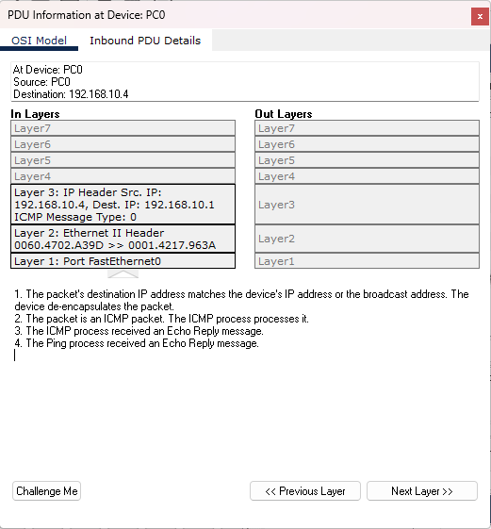

**B.3: Conclusion:**

(Students must write the conclusion as per the attainment of individual outcome listed above and learning/observation noted in section B.2)

We were able to implement the basic connection and sending echo messages from one device to another via switches using packet tracer software